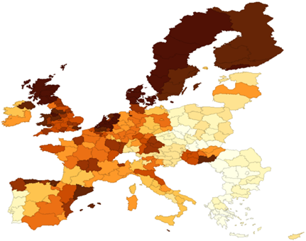
Figure 1. Standardized death rates of Mental and Behavioural Disorders, average 2008-2010, by region of residence, by deciles
Source: own study based on research.

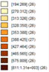
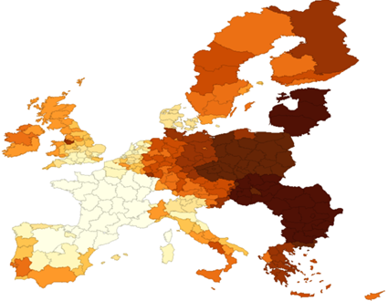
Figure 2. Standardized death rates of Diseases of the circulatory system, average 2008-2010, by region of residence, by deciles
Source: own study based on research.

