Author Name NAME, Co-author(s) Name NAME (Times New Roman, 12 point, Bold, First name in lowercase, surname in uppercase)
THIS IS AN EXAMPLE TITLE:
SUBTITLE SHOULD BE COMPLETED AFTER COLON
(TIMES NEW ROMAN, 12 POINT, BOLD, TITLE CASE AND CENTERED)
Abstract. Each paper should have a short abstract (not more than 100 words) as the first paragraph followed by a list of keywords. These guidelines include has prepared styles, and if needed descriptions of the fonts, spacing, and related information for producing your article.
Key words: workshop, proceedings, guidelines. (use minimum three keywords)
- SECTION TITLE – USE THIS STYLE FOR LEVEL ONE HEADINGS (TIMES NEW ROMAN, 10PT, BOLD, UPPERCASE WITH A SPACE (36PT BETWEEN PRECEDING PARAGRAPH AND THE NEW SUB TITLE AND A SPACE 19PT AFTER)
Paragraph - use this style for first paragraph, or to continue after an extract. (Normal text should be Times New Roman, 11pt. Please use single line spacing. There should be no indentation at the beginning of the first paragraph).
New paragraph - use this style when you need to begin a new paragraph. (Normal text should be Times New Roman, 11pt. Please use single line spacing. There should be indentation at the beginning of the next paragraphs). Longer fragments of text should be cited this way:
[…] For longer citates use this style (Text should be Times New Roman, 10 pt, 12 pt between preceding fragment and the new paragraph). Remember about added a source (Name, 2010).
New paragraph - use this style when you need to begin a new paragraph. (Normal text should be Times New Roman, 11pt. Please use single line spacing. There should be indentation at the beginning of the next paragraphs).
- SECTION TITLE – USE THIS STYLE FOR LEVEL ONE HEADINGS (TIMES NEW ROMAN, 10PT, BOLD, UPPERCASE WITH A SPACE (36PT BETWEEN PRECEDING PARAGRAPH AND THE NEW SUB TITLE AND A SPACE 19PT AFTER)
  - Subsection Title – Use this style for level two headings (Times New Roman, 10pt, bold and there should be a space 36 between preceding paragraph and the new sub title and a space 19pt after)
Paragraph - use this style for first paragraph, or to continue after an extract.
New paragraph - use this style when you need to begin a new paragraph.
Table 1. Targets of waste recycling rate for 2025 and 2030 at EU level
Type of waste | By 2025 | By 2030
All packaging | 65 | 70
Paper and cardboard | 75 | 85
Ferrous metals | 70 | 80
Glass | 70 | 75
Aluminum | 50 | 60
Plastic | 50 | 55
Wood | 25 | 30
Source: European Commission (2015).
Table 2. Evolution of the street network within the Historic Urban Core in light of the analysed plans
Time period (marks as in Fig. 1) | Average distance between intersections [m] | Street network density [km/100 ha] | Characteristic features
I  (early 19th century) | 129 | 0.37 | Pre-industrial Łódź, plan based on medieval layout. The surface area of the city was a small part of the HUC. The street network density was low, but the intensity of connections was the highest (short access routes).
II  (mid-19th century) | 270 | 4.38 | Plans of new city structures for industrialization. Street network expansion. On a global scale, a major increase in the density of the street network with a simultaneous decrease in the density of connections.
III  (the 1870s) | 251 | 5.45 | Stage where the urban structures designed earlier on were filled, inner densification of the street network.
IV  (late 19th century) | 172 | 7.91 | Filling the HUC area further. A relatively large increase in the length of streets and the density of their connections. Beginnings of the expansion of the street network outside of the studied area.
V  (121th century) | 162 | 8.71 | Only slight changes despite the passage of time (over 100 years), frozen street layout. Expansion and development of urban structures outside of the HUC.
Source: own work.
Paragraph - use this style for first paragraph, or to continue after an extract.
In text, tables and figures, use point as decimal separator, and a comma for thousand separator. Remember to refer to tables and figures in the text (ex. Fig. 1). Figures should have minimum 300 DPI.
Citations should be indicated in the text with the last name of the first author and year of publication (e.g. Fontagne et al., 2001). List of citations must be separated by semicolon (e.g. Isaken, 1997; Isaken and Hauge, 2002). References should be listed in alphabetical order and presented as shown in the example at the end of this document.
Caption and number every illustration and figure – the caption should appear in 10 pt Times New Roman, at the down of each figure. Illustrations and figures and their captions should be centered.
Caption and numer every table – the caption should appear in 10 pt Times New Roman, at the top of each table. Tables and their captions should be centred.
Use special styles for captions and sources.
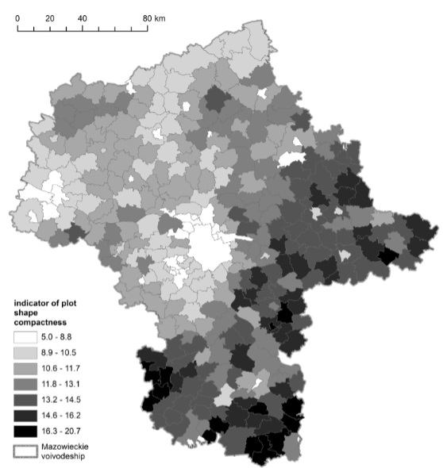
Fig. 1. Indicator of plot shape compactness by municipality in Mazowieckie voivodship
Source: own work based on the LPIS data.

Bulleted lists:
- First item;
- Second item;
- Third ite.
Numbered lists:
- First item;
- Second item;
- Third item.
- CONCLUSIONS AND DISCUSSION
Acknowledgments. Use this style to inform about the source of research funding etc.
REFERENCES
All references should be organized in alphabetical order. Examples of reference forrmats for articles, book chapters, reports etc. are presented below. Please note that separate lists for each type of sources are not recommended.
Citation in the text:
(Williams, 2019)
(Bressers and Kuks, 2003)
(Obersteg et al., 2019)

Bibliographic record format:

Articles in journals:
BERRUTI, G. and PALESTINO, M. F. (2019), ‘Contested land and blurred rights in the Land of Fires (Italy)’, International Planning Studies, 25 (3), pp. 277-288. https://doi.org/10.1080/ 13563475.2019.1584551
Books:
LADNES, A., KEUFFLER, N., BALDERSHEIM, H., HLEPAS, N., SWIANEWICZ, P., STEYVERS. K. and NAVARRO, C. (2019), Patterns of local autonomy in Europe, London: Macmillan. https://doi.org/10.1007/978-3-319-95642-8

Chapters in edited volumes:
KAIKA, M. and SWYNGEDOUW, E. (2011), ‘The Urbanization of Nature: Great Promises, Impasse, and New Beginnings’, [in:] BRIDGE, G. and WATSAN, S. (eds.), The New Blackwell Companion to the City, Cichester, Wiley-Blackwell, pp. 96-107. https://doi.org/10.1002/9781444395105.ch9

Reports:

Articles in web pages:
MEHTA, A. (2020), ‘Ukraine sees two paths for joining NTO. Will either work?’, Defense News, https://www.defensenews.com/smr/nato-2020-defined/2020/01/13/ukraine-sees-two-paths-for-joining-nato-will-either-work/ [accessed on: 29.06.2020].

Computer software:
AUTODESK Inc. (2020), AutoCAD Civil 3D. (Version 2020) [Computer software], Autodesk Inc., San Rafael CA.

Web pages:
ENoLL (2013), ENoLL Living Labs, http://www.openlivinglabs.eu/livinglabs [accessed on: 15.05.2019].
Standards :
OGC (2006), OGC, Web Map Service specifications, 1.3.0.

Theses:
MORISET, B. (2014), ‘Building new places of the creative economy: Towards the fourth place’, 2nd Geography of Innovation International Coference 2014 Utrecht University, Utrecht, 23-25 January 2014.

Reference section:

AUTODESK Inc. (2020), AutoCAD Civil 3D. (Version 2020) [Computer software], Autodesk Inc., San Rafael CA.
BERRUTI, G. and PALESTINO, M.F. (2019), ‘Contested land and blurred rights in the Land of Fires (Italy)’, International Planning Studies, 25 (3), pp. 277-288. https://doi.org/10.1080/ 13563475.2019.1584551
ENoLL (2013), ENoLL Living Labs, http://www.openlivinglabs.eu/livinglabs [accessed on: 15.05.2019].
KAIKA, M. and SWYNGEDOUW, E. (2011), ‘The Urbanization of Nature: Great Promises, Impasse, and New Beginnings’, [in:] BRIDGE, G. and WATSAN, S. (eds.), The New Blackwell Companion to the City, Cichester, Wiley-Blackwell, pp. 96-107. https://doi.org/10.1002/9781444395105.ch9
LADNES, A., KEUFFLER, N., BALDERSHEIM, H., HLEPAS, N., SWIANEWICZ, P., STEYVERS. K. and NAVARRO, C. (2019), Patterns of local autonomy in Europe, London: Macmillan. https://doi.org/10.1007/978-3-319-95642-8
MEHTA, A. (2020), ‘Ukraine sees two paths for joining NTO. Will either work?’, Defense News, https://www.defensenews.com/smr/nato-2020-defined/2020/01/13/ukraine-sees-two-paths-for-joining-nato-will-either-work/ [accessed on: 29.06.2020].
MORISET, B. (2014), ‘Building new places of the creative economy: Towards the fourth place’, 2nd Geography of Innovation International Coference 2014 Utrecht University, Utrecht, 23-25 January 2014.
OGC (2006), OGC, Web Map Service specifications, 1.3.0.

Name NAME, University of Lodz, Faculty of Geographical Sciences, Institute of the Built Environment and Spatial Policy, Street XX, XX-XXX, City, Country; e-mail: namename@example.com, ORCID: https://orcid.org/0000-0000-0000-0000 (Use Times New Roman, 10pt, remember about commas and adding ORCID)

